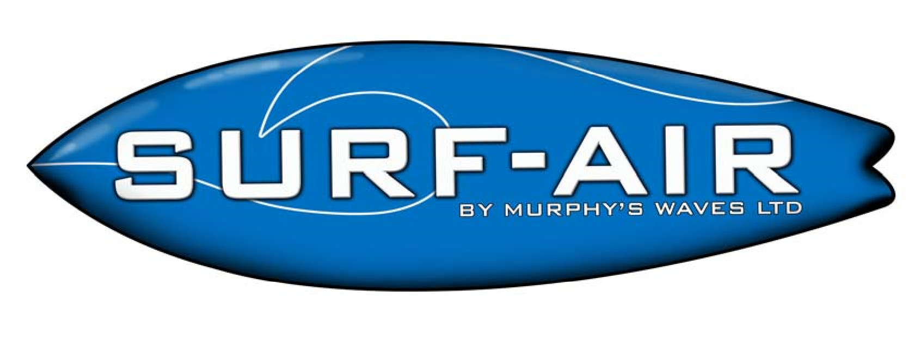
SAFETY CRITERIA
THIS IS AN EXTREME RIDE!!

Stingray users must comply with the following safety criteria;

- DO NOT enter unless you are + 4ft (1.2M) in height.
- DO NOT enter unless you are medically fit and capable of riding.
- DO NOT jump the queue
- DO NOT push or shove to get onto the ride
- DO NOT stand on the matting at the back of the Surf-Air, EXIT IMMEDIATELY • DO NOT carry out stunts, they are not permitted.
- DO NOT exceed numbers on the ride. Only 3 people at a time are allowed in these areas (Instructor + 1 Rider + 1 Rider).
- DO NOT enter the ride area until instructed to do so by the ride attendant.

- The ride must never be used by persons under the influence of alcohol, drugs or any substance that can affect or alter judgement and perception.

- DO pay attention during the training and instruction course prior to use.
- DO wait your turn; the Surf-Air is only designed for use by one person at a time.
- DO take extreme care on entry into the ride.
- DO have your rash vest on at all times.
- DO obey ALL signage and listen to staff instructions.
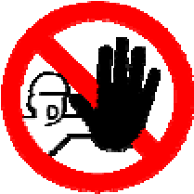 SAFETY EXCLUSIONS 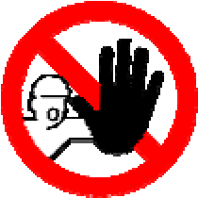
The following group are not permitted to use the Surf-Air;
- Expectant mothers or females who may be pregnant
- Children under 4ft (1.2M)
- Under 16 years of age without parent or guardian present
- Non-swimmers
- Persons with limiting physical conditions or those suffering illness, reduce mobility, obesity or any other recognised physical or mental ailment including but not limited to individuals who are overweight, or with previous or current neck, back, joint or heart problems.
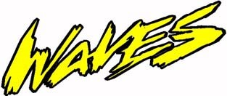
Murphys Waves LTD

